Document Ref: WDB-UG | Issue Date: 01/09/2005 | Version Number: 1.0
Contract REPORTNET 02020400/2004/394786/MAR/G3
PROJECT REPORTNET

Web DashBoards Service User Guide

Written by:  EUROPEAN DYNAMICS S.A.  Marios Vitos | Sign Off and Date:  01/09/2005 |  | Appraisal Authority:  European Environment Agency | Sign Off and Date:
Verified by:  EUROPEAN DYNAMICS S.A.  Nedeljko Pavlovic | Sign Off and Date:  01/09/2005 |  | Appraisal Authority:  European Environment Agency | Sign Off and Date:
Approved by:  EUROPEAN DYNAMICS S.A.  PROJECT MANAGER  Stelios Papastratos | Sign Off and Date:  01/09/2005 |  | Appraisal Authority:  European Environment Agency | Sign Off and Date:

Circulation List

Name | Company/Institution
Marios Vitos | EUROPEAN DYNAMICS S.A.
Stelios Papastratos | EUROPEAN DYNAMICS S.A.
Nedeljko Pavlovic | EUROPEAN DYNAMICS S.A.
Soren Roug | EEA
Jan Bliki | EEA
Stefan Jensen | EEA

Document History

Ver. | Date |  | Confidentiality | Description | Action | Pages
001 | 24/08/05 | Normal |  | First Draft | C | ALL
002 | 29/08/05 | Normal |  | First Revision | I | ALL
010 | 01/09/05 | Normal |  | Final Draft | R | ALL
(*) Action: I = Insert; R = Replace; C = Creation

Table of Contents

1. General Principles 6
XML 6
RSS 6
RDF 6
REPORTNET Unified Notification Service 6
User roles 6
WDS Channels 7
Dashboard Profile 7
Dashboard 7
2. Content Feeds 7
3. Authenticate User Account 9
4. WDS Administration 10
4.1 General Principles 10
4.2 Management of Channel Server 10
4.2.1 Create PULL Content Channel 11
4.2.2 Delete Channel 14
4.2.3 Edit Channel 15
4.3 Manage PUSH Channels 17
4.3.1 General Principles 17
4.3.2 Manage PUSH Channels 17
4.4 Dashboard Template Management 20
4.4.1 General Principles 20
4.4.2 Create New Dashboard Template 20
4.4.3 Edit Dashboard Template 22
4.4.4 Remove Dashboard Template 24
4.5 Stylesheet Management 25
4.5.1 General Principles 25
4.5.2 Add new Stylesheet 26
4.5.3 Stylesheet Editing 28
4.5.4 Stylesheet Deletion 29
4.5.5 Download Stylesheet 31
4.5.6 Stylesheet Test 32
4.6 Manage UI template 34
4.6.1 General Principles 34
4.6.2 Header/Footer Edit 34
5. WDS User FEATURES 38
5.1 General Principles 38
5.2 View Dashboard 38
5.2.1 Access the Dashboard 38
5.2.2 Move items on the dashboard 39
5.2.3 The PUSH Channels 40
5.3 Manage Dashboard Profile 41
5.3.1 Manage Dashboard Profile Preferences 42
5.3.2 Manage Profile Channels 43
6. RPC User FEATURES 45
6.1 WDS XML-RPC 45
6.2 WDS RPC Users UI 46
6.2.1 RPC User PUSH Channel Creation 46

Table of Figures

Figure 1: Example of RSS document 8
Figure 2: WDS Login Page 9
Figure 3: WDS welcome page 10
Figure 4: PULL Channels list 11
Figure 5: Channel creation step 1 12
Figure 6: Create channel - Definition of channel properties 13
Figure 7: Channel metadata elements selection 13
Figure 8: Channel Creation Step 3 - Channel Preview 14
Figure 9: Delete Channel confirmation prompt 15
Figure 10: Edit Channel page 16
Figure 11: Push Channel Edit 18
Figure 12: PUSH Channel Metadata 19
Figure 13: PUSH Channels List 20
Figure 14: Dashboards list 21
Figure 15: Create Dashboard 22
Figure 16: Edit Dashboard 23
Figure 17: Confirmation prompt for successful deletion of Dashboard 25
Figure 18: Stylesheet section 26
Figure 19: Notification Template Creation page 27
Figure 20: Edit Stylesheet 29
Figure 21: Stylesheet deletion confirmation prompt 30
Figure 22: Transformation Scenario page 32
Figure 23: Stylesheet test results 33
Figure 24: Footer template matrix 34
Figure 25: Header Management page 35
Figure 26: Matrix cell selection 36
Figure 27: Image Manager 37
Figure 28: A user can access the dashboard without being logged in. 39
Figure 29: Dashboard Channel Direction functions 39
Figure 30: My Dashboard - Channel Move 40
Figure 31: UNS channel and "edit" button 41
Figure 32: UNS Channel edit page 41
Figure 33: Profile preferences 42
Figure 34: Profile Channels 44
Figure 35: RPC User welcome screen 46
Figure 36: PUSH Channels List 47
Figure 37: PUSH Channel Creation form 48

General Principles

The objective of the web dashboards service (WDS) is to provide to the REPORTNET users with dashboards presenting summary information harvested from REPORTNET modules, as well as from other Agency systems based on predefined profiles. The service improves cooperation and transparency and ease retrieval of information from REPORTNET.
WDB defines some terminology in order to describe the functionality of the application. The following terms are very common:

XML
The Extensible Markup Language (XML) was designed to provide a means for information to be served, received, and processed on the Web in the way that is now possible with HTML.

RSS
RSS is an acronym for Rich Site Summary (or Really Simple Syndication), an XML format for distributing news headlines on the Web, also known as syndication.

RDF
Resource Description Framework is a formal data model from the W3C using XML for the description of web resources using machine readable metadata.

REPORTNET Unified Notification Service
The Unified Notification Service (UNS) is part of the EEA REPORTNET architecture. It provides key stakeholders a notification mechanism for delivery of information harvested from REPORTNET modules, as well as from other Agency systems based on predefined profiles. Each registered REPORTNET user may define a personal notification profile allowing him/her to receive notifications on the desired REPORTNET information by email, Jabber, RSS or Web Dashboards.

User roles
Roles are named groups of related privileges that REPORTNET Web Dashboards Service grant to users or other roles. Access to the REPORTNET Web Dashboards Service will be granted at 3 levels of users:
- WDS Administrator: Is a registered user who is allowed to perform the WDS administrative operations. This user may also include privileges of the WDS User.
- WDS User: Is a registered user who is able to manage his/her own subscriptions in the WDS.
- WDS RPC User: Is a registered user who can access the WDS programmatically in order to create new PUSH channels or the push RDF formed data. This user is also able to see his/ her own PUSH channels by using the WDS user interface, as well as to create new PUSH channels.

WDS Channels
WDS Content channels are used for harvesting data. There are two types of channels; the PULL and PUSH channels. Pull Channels are represented in the WDS as feeds provided by external web applications from which WDS is pulling data, whereas PUSH Channels are used by external systems to send events data to the WDS. REPORTNET users will be able to include these channels in their dashboard profiles and visually check harvested data on the information panel called “dashboard”.

Dashboard Profile
A dashboard profile is the functionality which enables REPORTNET users to personalize the look and content of their dashboard.

Dashboard
A dashboard is generally considered as an information panel. In the framework of REPORTNET, it is the section where the information of the WDS channels is posted. Each WDS user has the possibility to personalize the information which is displayed in the dashboard.

Content Feeds

The WDS application can read and extract data from RSS and RDF documents
The characteristic of both of these markup languages is that they are designed to store not only content but also additional information describing the content.

For example, in RSS, the content is stored in channels and the channel’s sub-elements: items.
A channel may contain any number of items which represent an event or a summary of the event and a link leading to the page with the full description of the event.

Each item contains some metadata elements that describe its content, such as:
- title: the title of the item
- description: a summary/introduction of the item
- link: the URL where the full text is available
- author: the name/e-mail of the author of the item
- pubDate: the date when the item was published
- guid: a unique identifier for each item

In the following Figure 1 a typical RSS file is presented.
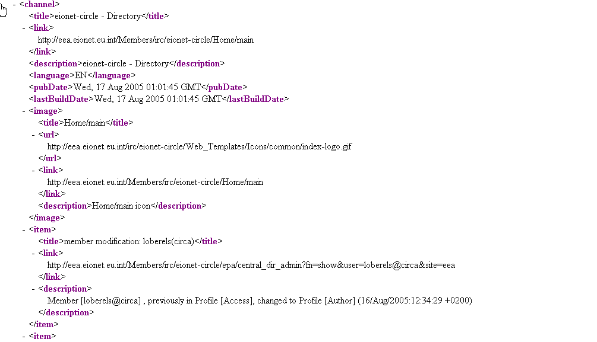

Figure 1: Example of RSS document

These metadata elements are optional but at least a title or a description must be present in order for the content to be meaningful.
The same principles stand also for RDF (Resource Description Framework) type of documents. The only difference in the case of RDF is the syntax of the document itself. In general RDF may provide other type of resources than simple RSS items.

WDS in turn, is able to browse through such structured documents and identify distinct resources. The system will display all such identified elements to the dashboard for WDS users to see (see: View Dashboard).

Additionally, it is possible to insert such structured documents into the WDS. This function is available only to event channels that operate under PUSH mode (see: Manage PUSH Channels)

WDS has a capability to handle all versions of RSS and RDF in a way that is transparent to the user.

Authenticate User Account

In WDS, users may log in the application in order to view their dashboard. Administrators have additional privileges in terms of managing application parameters and defining new WDS channels (See: WDS Administration).
Before performing any actions on WDB, the user must authenticate to the system as follows:
- The authentication page can be invoked by clicking on the “Login” icon at the top of the navigation bar
- Insert the username/password combination
- Click on the OK button

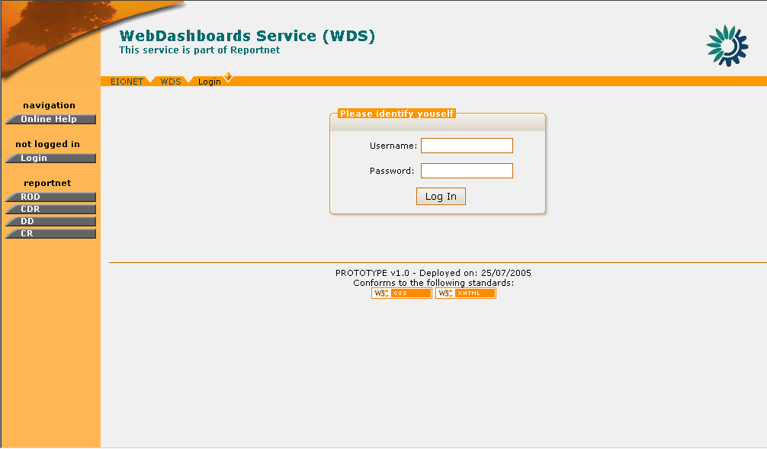

Figure 2: WDS Login Page

After a successful login, the navigation bar is refreshed with the operations that correspond to the profile of the user signed-in.

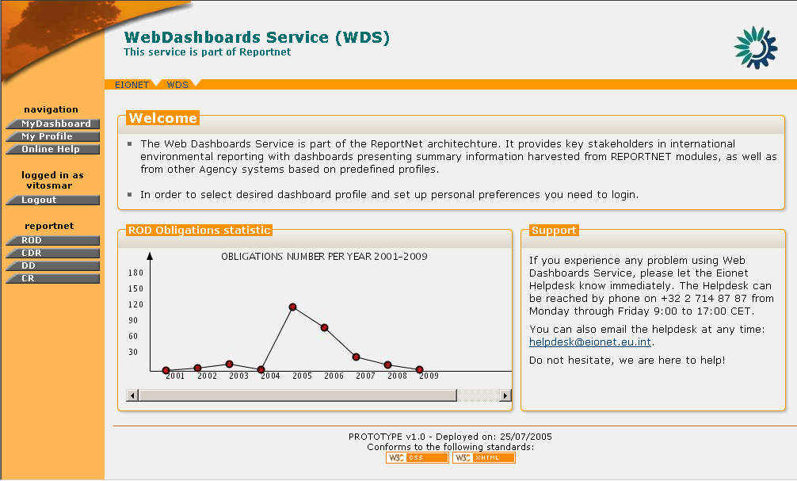

Figure 3: WDS welcome page

In order to logout, the user must select the “Logout” button on the navigation menu. By clicking on this button, the user will be disconnected from the application and the navigation menu will be reduced to the one shown in Figure 2: WDS Login Page

WDS Administration

General Principles

A WDS Administrator is a privileged user who is responsible for managing the WDS. The system features which will perform administrative operations are only be authorized to this User class. The responsibilities of the administrator are:
- Management of the channel server (adding, modifying and deleting of channels)
- Management of the dashboards (adding, modifying and deleting of dashboards)
- Management of the defined parts of the User Interface
- Management of the stylesheets (add, modify, remove)

Management of Channel Server

Create PULL Content Channel

A Channel created in the “PULL” mode will be used to harvest information from existing data feeds.
In order to create a “PULL” Channel the user must be logged in as WDS Administrator.
If you have administrator privileges, then the following steps must be followed:

STEP 1 – Login
If you are not already logged in, see: Authenticate User Account.

STEP 2 – Click on “Channels” button on the navigation bar.
Arrive at the Channels section and make sure the “Pull channels” tab is selected. The user may view the list of existing PULL channels.

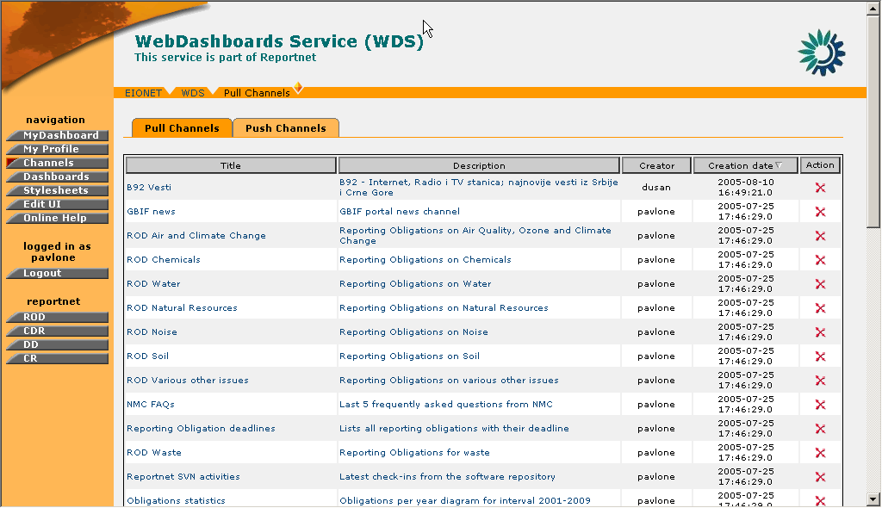

Figure 4: PULL Channels list

STEP 3 – Click on “Create” button
Clicking on the “Create” button will take the user on the create channel menu. This is a 3-step procedure.

STEP 4 – Insert the channel URL.
In order for the channel to be successfully created, channel URL must correspond to an existing content feed provided by external web application. Additionally, in this step the user also defines the rate in which the information of this channel will be updated (refresh rate).

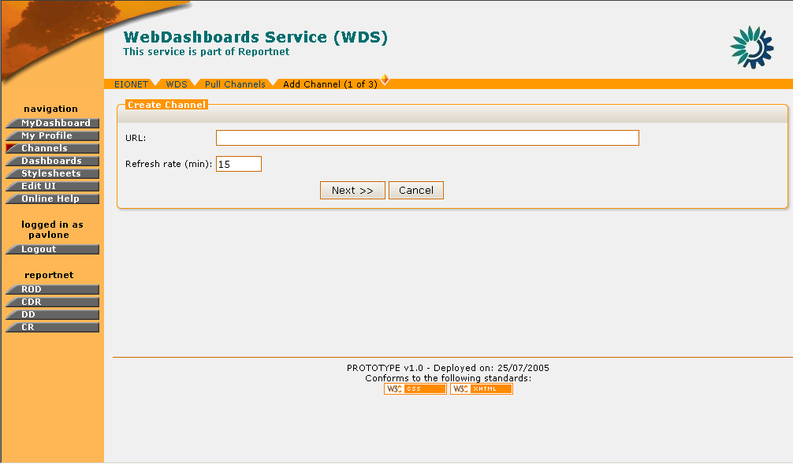

Figure 5: Channel creation step 1

STEP 5 – Define Channel Properties
After the insertion of the URL, the user may define the properties of the channel such as its title, description, the user classes which will be able to access this channel, as well as the way the channel will be displayed in the dashboards.
Certain values such as the channel title and description may be automatically filled-in if they are included in the channel’s RSS/RDF header. However, the user may assign new values if needed.
Additionally, the user can define which user classes will be able to access this channel by selecting from the “available roles” and adding them to the roles list. If no roles are selected, then the channel will be available to all users.
Finally, the user needs to define the format in which the channel information will be displayed in the dashboards. The available options is to select a predefined stylesheet (see: Stylesheet Management) which will read the RSS/RDF feed and display the channel information in a standardized way, or let the user define which of the channel metadata will be displayed in the dashboard by selecting distinct metadata elements (see: Content Feeds).
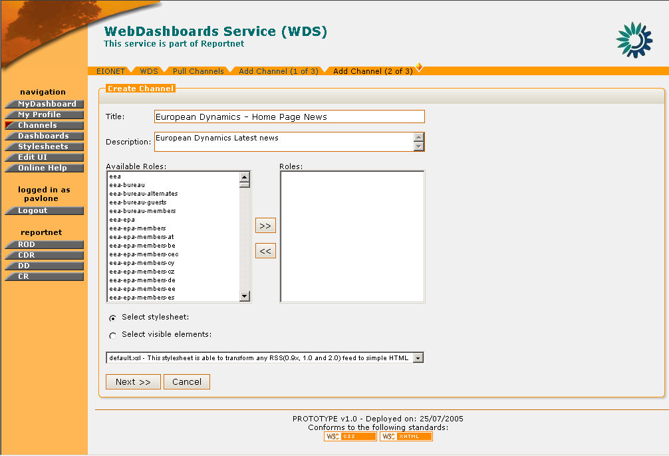
Figure 6: Create channel - Definition of channel properties

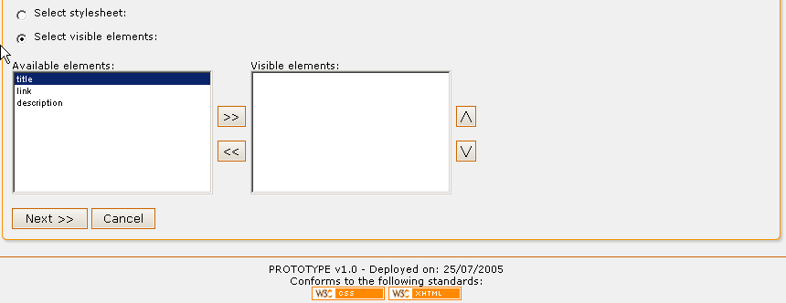

Figure 7: Channel metadata elements selection

STEP 6 – Preview and Save the channel
The user receives a preview of the channel according to the information entered in the previous steps. The channel is still not created at this stage. The user must confirm the channel creation by pushing the “Save” button. Otherwise, the user may cancel the operation.
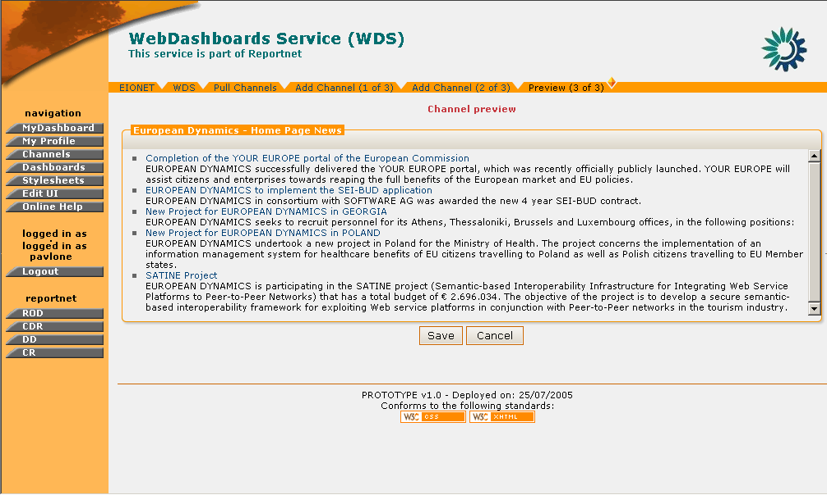
Figure 8: Channel Creation Step 3 - Channel Preview

So, in summary:

Step | Create a new Channel
1 | Login
2 | Click on “Channels” icon
3 | Click on “Create” button
4 | Insert Channel URL
5 | Define Channel Properties
6 | Preview and Save the Channel

Delete Channel

In order to delete a Channel the user must be logged in as WDS Administrator.
If the user has administrator privileges, then the following steps must be followed:

STEP 1 – Login
If you are not already logged in, see: Authenticate User Account.

STEP 2 – Click on “Channels” button on the navigation bar.
Arriving at the Channels section, the user may view the list of existing channels (Figure 4: PULL Channels list).

STEP 3 – Click the (Delete Channel) icon.
You may select which channel to delete by clicking the delete channel icon. This icon is located at the rightmost column of the channel list

STEP 4 – Confirm Channel Deletion
For safety reasons, the user receives a confirmation prompt for the delete channel action. If the user confirms, then the channel is deleted from the WDS database.

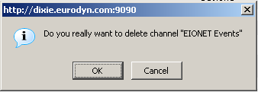

Figure 9: Delete Channel confirmation prompt

So, in summary:

Step | Delete a Channel
1 | Login
2 | Click on “Channels” icon
3 | Click on “Delete Channel” button
4 | Confirm Channel deletion
5 | Delete a Channel

Edit Channel

In order to edit a Channel you must be logged in as WDS Administrator.
If the user has administrator privileges, then the following steps must be followed:

STEP 1 – Login
If you are not already logged in, see: Authenticate User Account.

STEP 2 – Click on “Channels” button on the navigation bar.
Arriving at the Channels section, the user may view the list of existing channels (Figure 4: PULL Channels list).

STEP 3 – Click on any Content Channel on the list
By clicking on the channel you will go through the 3-step channel definition described in Create PULL Content Channel section.

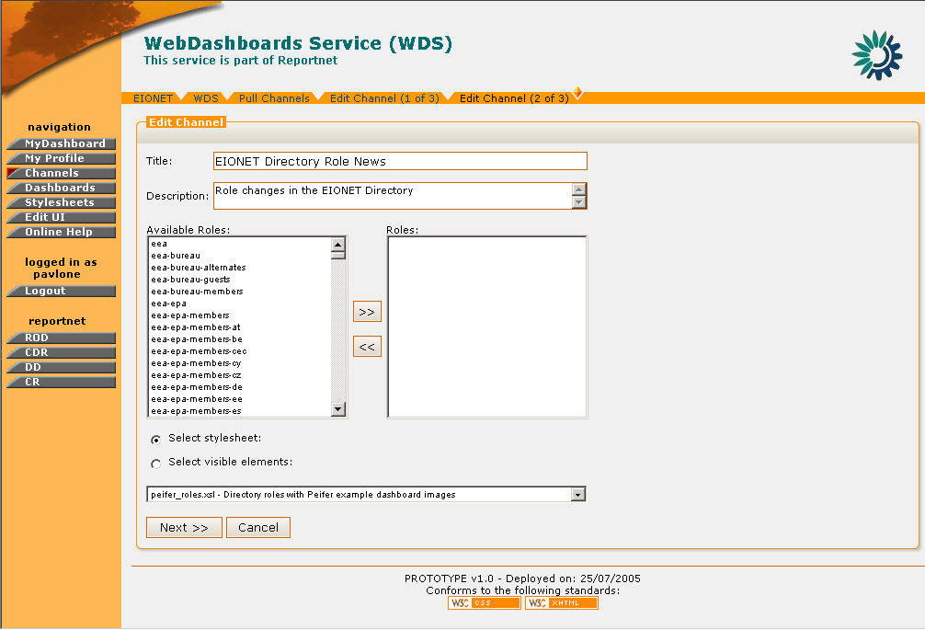

Figure 10: Edit Channel page

STEP 4 – Edit Channel fields
The user may edit any of the available sections (title, description, URL, refresh interval, roles, stylesheet/visible elements selection) and proceed to the preview of the channel by selecting “Next”.

STEP 5 – Preview and Save Channel
The user previews the channel and may press “Save” for the changes to take effect or “Cancel” to discard them.

So, in summary:

Step | Edit a Channel
1 | Login
2 | Click on “Channels” buton
3 | Click on any Content Channel on the list
4 | Edit Channel fields
5 | Preview and Save Channel

Manage PUSH Channels

General Principles

Push channels are content services that are managed in WDS. Contrary to the PULL channels, the channels that operate under PUSH mode enable external systems to send events to them.

Manage PUSH Channels

PUSH Channels cannot be created through the WDS interface by Administrators. They are created by external applications via RPC API or via the User interface. So an external system supplied by appropriate WDS credentials actually creates the push channels.

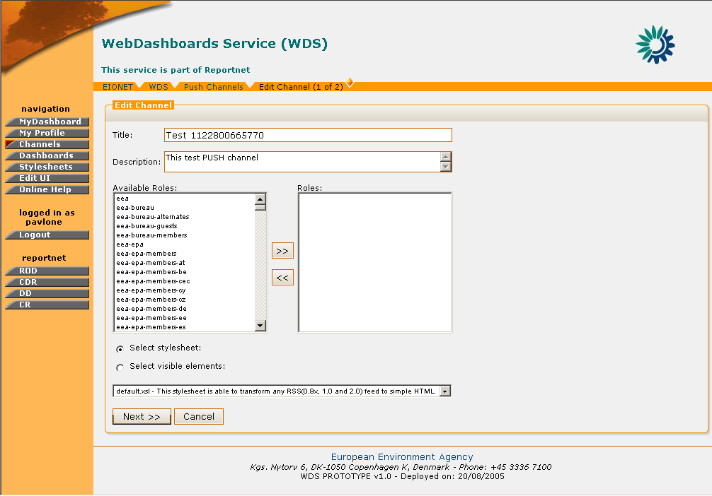
Figure 11: Push Channel Edit

Nevertheless, the WDS administrator is responsible for the management of the PUSH channels and can enable or disable them at any time.
More specifically, when the administrator visits the PUSH Channels tab under the “Channels” section, a list of the existing PUSH channels is displayed.
Upon the creation of the channel, the name and description are assigned automatically by the system. However, the administrator can edit them and give more meaningful titles.
In order to do so, the user has to click on the name of the PUSH channel and arrive at the Channel Edit page. In this section, the user can also edit the user classes that will be able to access this channel, as well as define the format of the channel contents (stylesheet or selection of visible elements). The user then may press “Next” in order to preview the selected configuration and proceed with the saving of the changes or cancel the edit operation.
Similarly to the PULL channels, the PUSH channels also have metadata elements which can be selected as visible elements. However, these metadata elements are not defined during the creation of the channel nor can the WDS administrator manage them directly. The PUSH channel metadata are defined along with the PUSH of events and subsequently, the WDS administrator may view them and manage them in the same way as in the case of PULL channels.

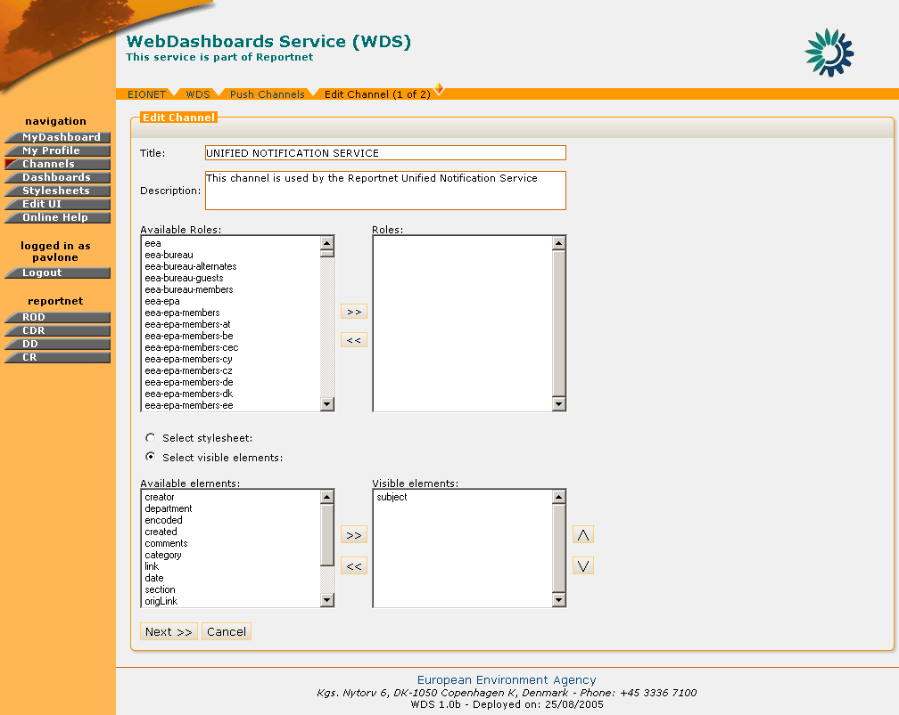
Figure 12: PUSH Channel Metadata

As mentioned earlier, the administrator can enable or disable any PUSH Channel. This is performed by clicking the corresponding action button on the channel list.
If the channel is under status “enabled”, the user should click the “disable channel” icon in order to disable it, or if the channel is under status “disabled, the user should click the “enable channel” icon to enable the service.
When a channel is under status disabled, then it is not possible for external systems to push events data neither users to add that channel on their dashboard profile.
Furthermore, the user is able to delete an existing PUSH channel by clicking the “delete channel” icon on the action column.

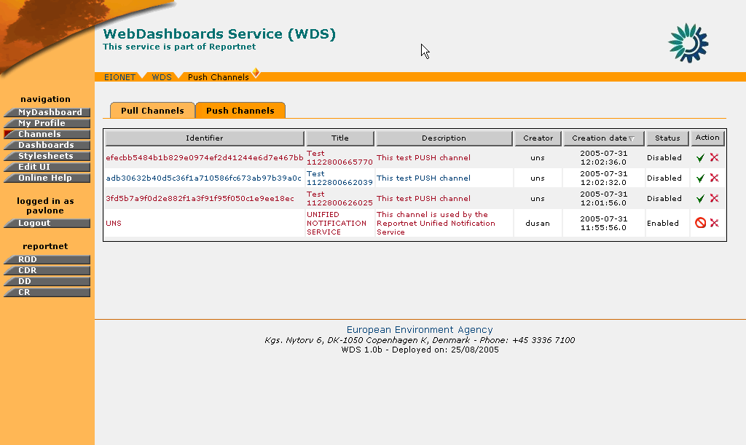
Figure 13: PUSH Channels List

Dashboard Template Management

General Principles

The Dashboard template functionality is used by administrators to group channels into greater entities. In this manner, the administrator is able to manage channels in groups (for example: according to their subject).
The purpose of these predefined Dashboards is to allow simple users to select which dashboard template they wish to view instead of selecting channels one-by-one.

Create New Dashboard Template

In order to create a new Dashboard template the user must be logged in as WDS Administrator.
If the user has administrator privileges, then the following steps must be followed:

STEP 1 – Login
If you are not already logged in, see: Authenticate User Account.

STEP 2 – Click on the “Dashboards” button on the navigation bar.
Arriving at the Dashboards section, the user can view the list of existing dashboard templates.

STEP 3 – Click on the “Create Dashboard” button.
By clicking on this button the user will be directed to the Notification Profile creation dialogue.

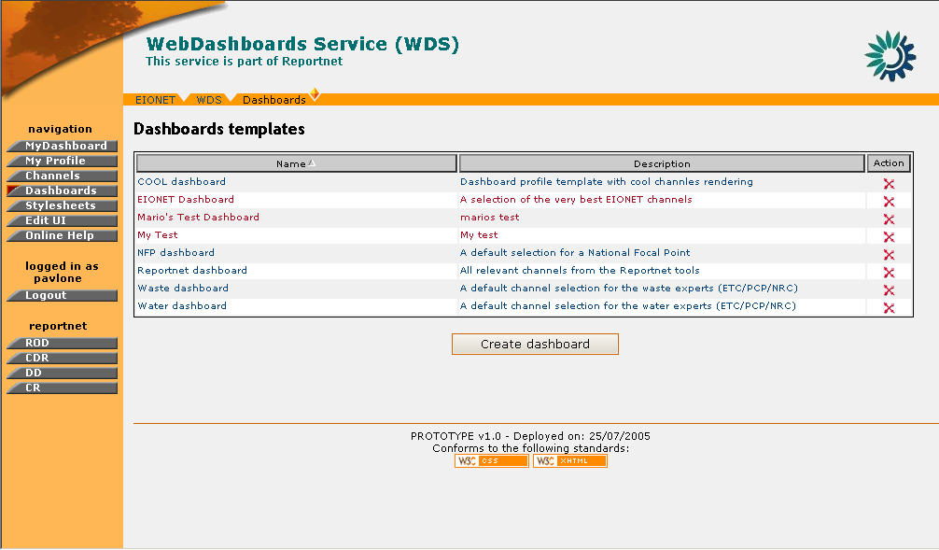

Figure 14: Dashboards list

STEP 4 – Fill-in required information
The following fields are available
- Name: Dashboard template name
- Description: A short description about the dashboard template
- Available Channels/Selected channels: The list of channels which will be available for this notification template.

The user must specify a name/description for the new Dashboard template. In addition, he/she must select the channels that will be assigned to it. A channel can be assigned to more than one Dashboard templates.

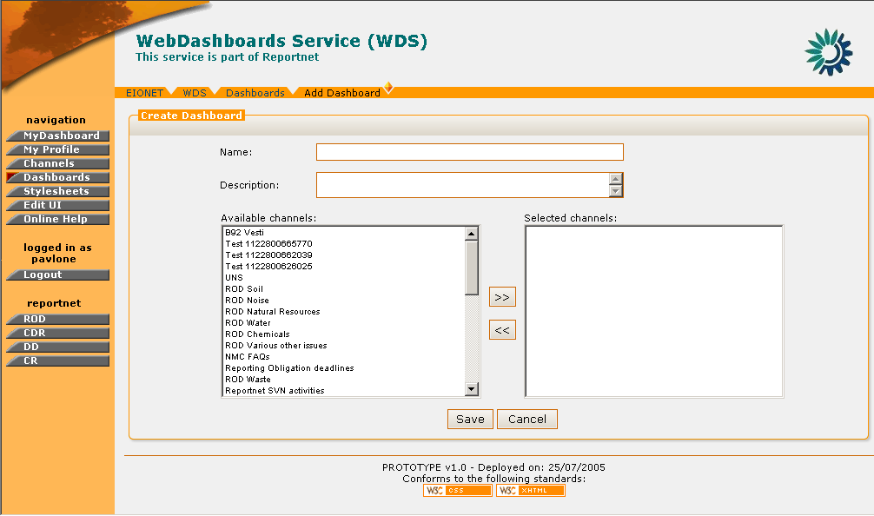
Figure 15: Create Dashboard

STEP 5 – Create the Dashboard Template
After all the required information are inserted, press the “Save” button in order for the new Dashboard to be created. A corresponding notification message will be displayed.

So, in summary:

Step | Create a new Dashboard Template
1 | Login
2 | Click on “Dashboards” button
3 | Click on the “Create Dashboard” button
4 | Fill-in Required information
5 | Create the Dashboard

Edit Dashboard Template

In order to edit a Dashboard template the user must be logged in as WDS Administrator.
If the user has administrator privileges, then the following steps must be followed:

STEP 1 – Login
If you are not already logged in, see Authenticate User Account.

STEP 2 – Click on “Dashboards” button on the navigation bar.
Arriving at the Dashboards section, the user can view the list of Dashboard templates.

STEP 3 – Select Dashboard template to be edited
To edit a Dashboard template, click on the name of an existing one. You will be redirected to the “Edit Dashboard” page.

STEP 4 – Edit Dashboard
Any of the Dashboard’s fields can be edited. Channels can be added / removed and the name/description of the dashboard can be changed.

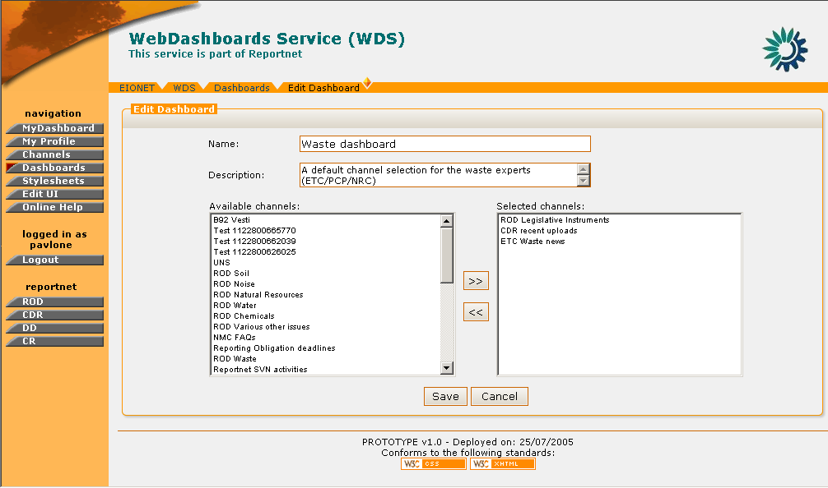

Figure 16: Edit Dashboard

STEP 5 – Save Dashboard Template
Press the “Save” button on the bottom of the edit screen in order for the changes to take effect.

In summary:

Step | Edit Dashboard Template
1 | Login
2 | Click on “Dashboards” button
3 | Select Dashboard template to be edited
4 | Edit Dashboard template
5 | Save Dashboard template

Remove Dashboard Template

In order to delete a Dashboard template the user must be logged in as WDS Administrator.
If the user has administrator privileges, then the following steps must be followed:

STEP 1 – Login
If you are not already logged in, see Authenticate User Account.

STEP 2 – Click on “Dashboards” button on the navigation bar.
Arriving at the Dashboards section, the user can view the list of existing dashboard templates.

STEP 3 – Select Dashboard template to be deleted
To delete a profile, you must select it by ticking the box on the left to its name.

STEP 4 – Deletion of Dashboard template
Press the “Delete Dashboard” icon in order for the selected Dashboard to be deleted. The system will ask the user for confirmation. If the user confirms, the dashboard template is deleted and the corresponding information message will be displayed.

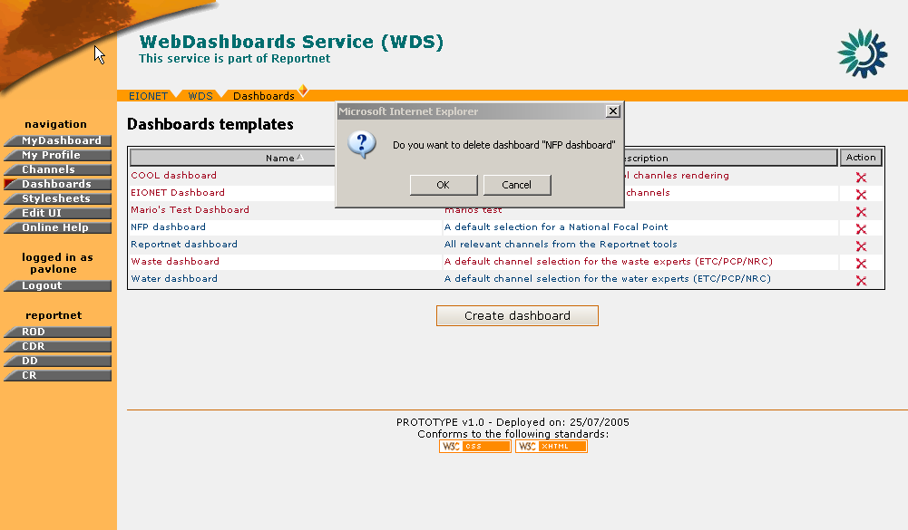

Figure 17: Confirmation prompt for successful deletion of Dashboard

In summary:

Step | Delete Dashboard Template
1 | Login
2 | Click on “Dashboard” button
3 | Select Dashboard template to be deleted
4 | Delete Dashboard template

Stylesheet Management

General Principles

The format of the information which is displayed in the WDS is managed with the definition of stylesheets. These stylesheets are XSL documents which dictate to the WDS how to display the information retrieved by the content channels.
The WDS administrator has the possibility to:
- Add new stylesheet
- Remove stylesheet
- Edit stylesheet
- Test stylesheet
- Download stylesheet

Add new Stylesheet

In order to add a new Stylesheet the user must be logged in as WDS Administrator.
If the user has administrator privileges, then the following steps must be followed:

STEP 1 – Login
If you are not already logged in, see: Authenticate User Account.

STEP 2 – Click on “Stylesheets” button on the navigation bar.
Arriving at the Stylesheets section, the user can view the list of existing notification templates.

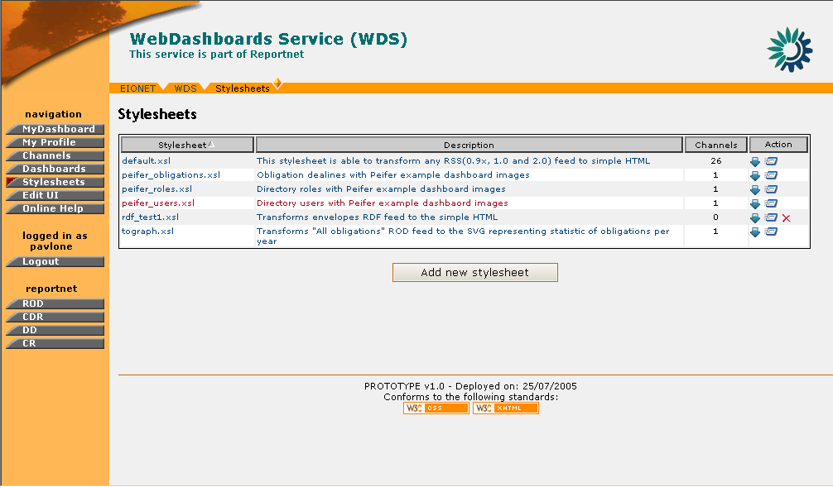
Figure 18: Stylesheet section

STEP 3 – Click on “Add new Stylesheet” button
In order to create a new stylesheet, the user must click on the corresponding button and arrive at the stylesheet creation page.

STEP 4 – Fill-in required information
The following fields are available
- Name: Stylesheet name
- Description: A short description of the stylesheet
- Load from file: The user can load the stylesheet content directly from a file stored on a local system.
- Stylesheet: This is a text field where content of the stylesheet can be entered directly.
The user has the option either to insert the text of the XSL stylesheet document in the “Stylesheet” text field, or load it from a file.
The user must also define a stylesheet name as well as a description of what this stylesheet’s purpose is.

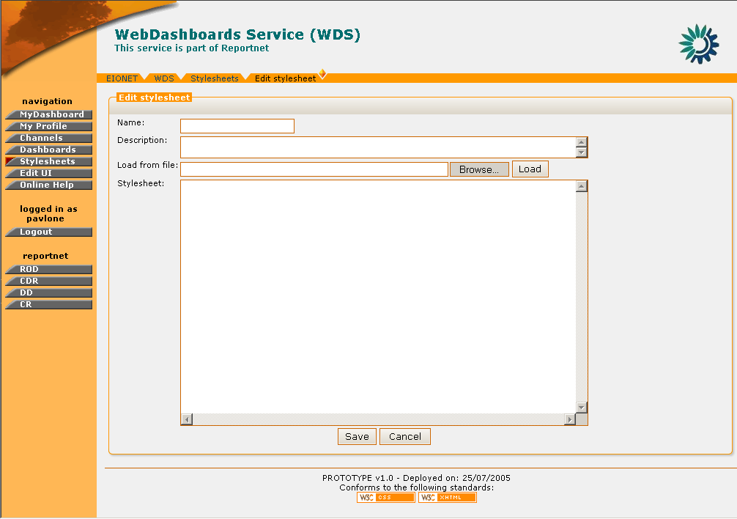

Figure 19: Notification Template Creation page

STEP 5 – Create Stylesheet
After inserting all the required information, press the “Save” button for the new Stylesheet to be created.

In summary:

Step | Add new Stylesheet
1 | Login
2 | Click on “Stylesheet” button
3 | Click on “add new Stylesheet” button
4 | Fill-in required information
5 | Create Stylesheet

Stylesheet Editing

In order to edit a Stylesheet the user must be logged in as WDS Administrator.
If the user has administrator privileges, then the following steps must be followed:

STEP 1 – Login
If you are not already logged in, see: Authenticate User Account.

STEP 2 – Click on “Stylesheets” button on the navigation bar.
Arriving at the Stylesheets section, the user can view the list of existing notification templates.

STEP 3 – Select Stylesheet to edit
Click on the name of an existing stylesheet in order to edit it. This will take you to the “Edit Stylesheet” page where the current stylesheet text is displayed.

STEP 4 – Edit Stylesheet
Any of the Stylesheet’s fields can be edited. This includes also the possibility to edit the text of the stylesheet or load a new XSL file instead.

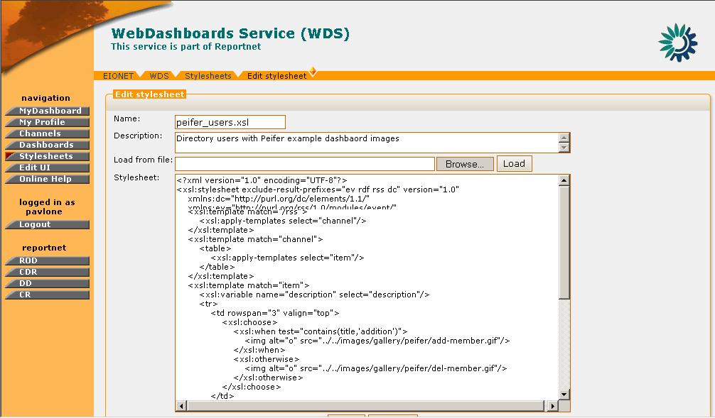
Figure 20: Edit Stylesheet

STEP 5 – Save Stylesheet
The user must press the “Save” button in order for the changes to take effect.

In summary:

Step | Edit Stylesheet
1 | Login
2 | Click on “Stylesheet” button
3 | Select Stylesheet to edit
4 | Edit Stylesheet
5 | Save Stylesheet

Stylesheet Deletion

The following requirements exist for the deletion of stylesheets:
- In order to delete a Stylesheet the user must be logged in as WDS Administrator.
- No content channels must use the stylesheet to be deleted.
If both of these requirements are satisfied, then the following steps must be followed:

STEP 1 – Login
If you are not already logged in, see: Authenticate User Account.

STEP 2 – Click on “Stylesheets” button on the navigation bar.
Arriving at the Stylesheets section, the user can view the list of Stylesheets.

STEP 3 – Select Stylesheet to delete
Select the “Delete Stylesheet” icon in the rightmost column of the stylesheet you wish to be removed. This icon will be displayed only for the stylesheets that are not used by any content channels.

STEP 4 – Confirm Stylesheet Deletion
WDS will prompt the user for a confirmation of the stylesheet deletion. If the user confirms, then the stylesheet will be removed from the system.

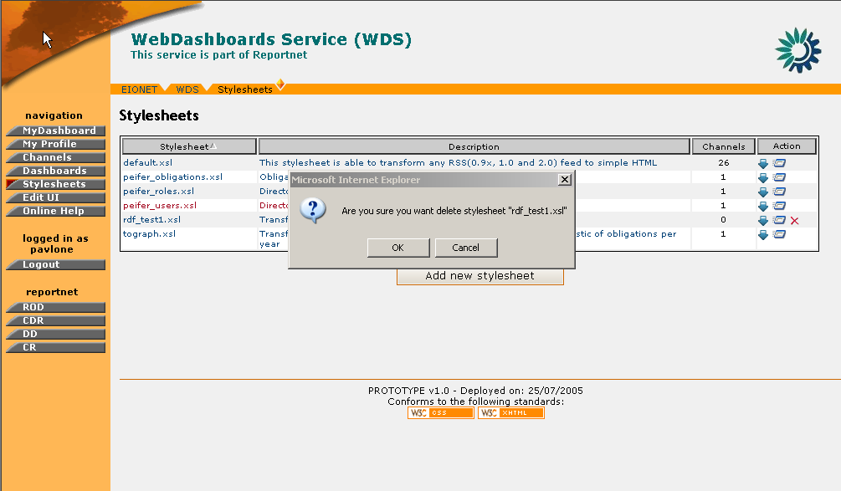

Figure 21: Stylesheet deletion confirmation prompt

In summary:

Step | Stylesheet Deletion
1 | Login
2 | Click on “Stylesheets” button
3 | Select Stylesheet to delete
4 | Confirm Stylesheet Deletion

Download Stylesheet

In same cases users may want to edit a stylesheet locally by using some advanced editor and then upload it back to the WDS. In order to facilitate this, WDS allows users to download existing stylesheets. In order to download a Stylesheet the user must be logged in as WDS Administrator.

STEP 1 – Login
If you are not already logged in, see: Authenticate User Account.

STEP 2 – Click on “Stylesheets” button on the navigation bar.
Arriving at the Stylesheets section, the user can view the list of Stylesheets.

STEP 3 – Select Stylesheet to download
Select the “Download Stylesheet” icon in the rightmost column of the stylesheet you wish to test.

STEP 4 – Download Stylesheet
The user is prompted for the stylesheet download and must select either to save the XSL file or open it.

In summary:

Step | Stylesheet Download
1 | Login
2 | Click on “Stylesheets” button
3 | Select Stylesheet to download
4 | Download Stylesheet

Stylesheet Test

With this functionality, the administrator may test the effect that a stylesheet will have on the display of a content feed.

In order to test a Stylesheet the user must be logged in as WDS Administrator.

STEP 1 – Login
If you are not already logged in, see: Authenticate User Account.

STEP 2 – Click on “Stylesheets” button on the navigation bar.
Arriving at the Stylesheets section, the user can view the list of Stylesheets.

STEP 3 – Select Stylesheet to test
Select the “Test Stylesheet” icon in the rightmost column of the stylesheet you wish to test.

STEP 4 – Define Transformation Scenario
The user is directed to the “Transformation Scenario” page where he/she can test the selected stylesheet against an existing content channel or an external URL.
When the content feed to be tested has been selected, the user may push “Run Test” button.

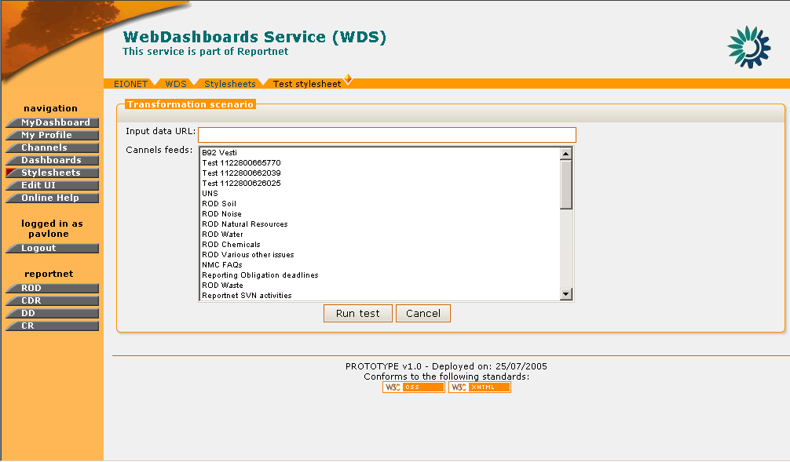
Figure 22: Transformation Scenario page

STEP 5 – View Results
In response to step 4, WDS will return to the user the results of the stylesheet test. This will be result of applying the specific stylesheet on the chosen content feed.

Important Note: Since some stylesheets are specially designed to handle very specific types of content feeds, it is quite possible that the test may yield unformatted or even no results when the chosen content feed does not match the stylesheet type.

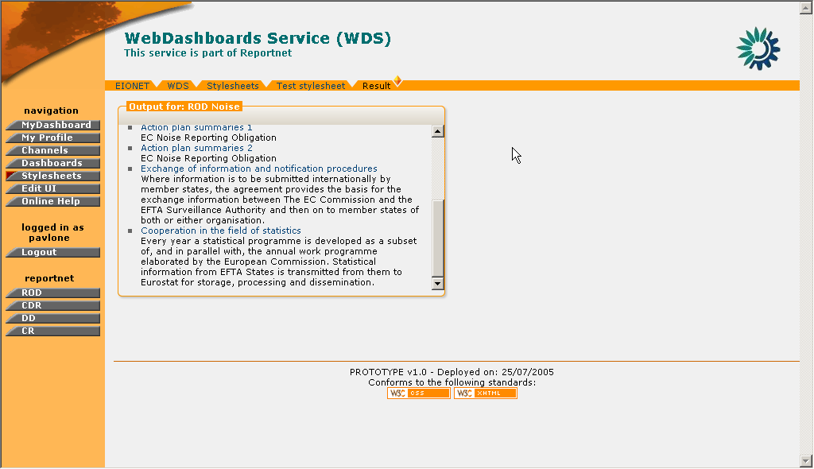
Figure 23: Stylesheet test results

In summary:

Step | Stylesheet Test
1 | Login
2 | Click on “Stylesheets” button
3 | Select Stylesheet to test
4 | Define Transformation Scenario
5 | View Results

Manage UI template

General Principles

Through the UI management toolkit the administrator has the ability to change some elements of the user interface. These elements are:
- Header
- Footer
The administrator can change the content of these UI elements by adding/removing images, text and/or hyperlinks. The layout and positioning of this content is controlled via a matrix 5x3. This matrix represents the available area for the header/footer. This area is divided in cells and each cell, may be used as a container for the information the user wants to display.

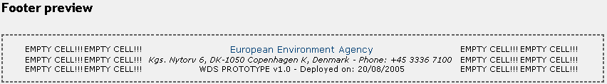

Figure 24: Footer template matrix

For more details on how to add/edit content in the header/footer, please see section 4.6.2

Header/Footer Edit

In order to edit the content of the Header/Footer, the user must be logged in as WDS Administrator.
If the user has administrator privileges, then the following steps must be followed:

STEP 1 – Login
If you are not already logged in, see: Authenticate User Account.

STEP 2 – Click on “UI Manage” button on the navigation bar.
From here you will be able to select which one of the Header/Footer you wish to edit by clicking the appropriate tag buttons.

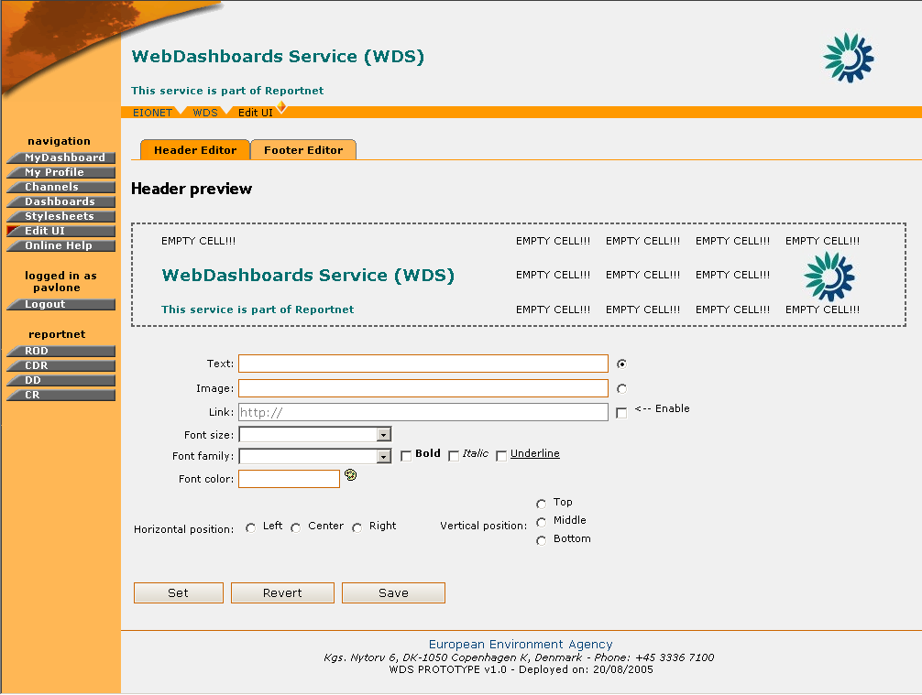

Figure 25: Header Management page

STEP 3 – Select and Edit Matrix Cell
Once clicked on the desired tab, the Header/Footer preview page will be displayed. This consists of the Preview Matrix, the different types of input fields (plain text, image, hyperlink) and the formatting options.
In order for the user to perform a change on the UI, a matrix cell must be selected. This is done by performing a mouse click on the matrix. The indicated cell will be denoted then with a red rectangle around it.

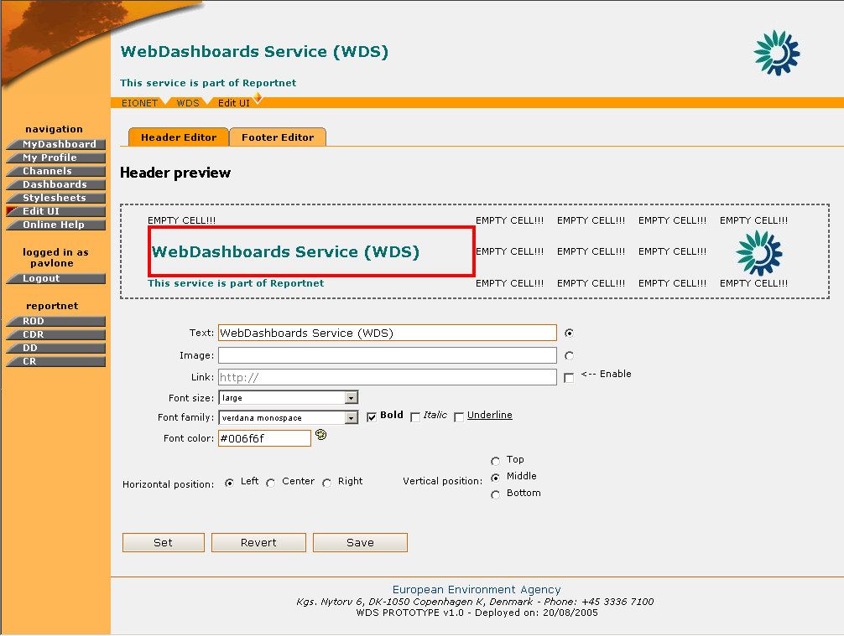

Figure 26: Matrix cell selection

As soon as this is done, the user may enter the text, image, hyperlink to be added on the header/footer and add any further formatting using the available tools.
In the case of a link, the user has to enter the text to appear on the UI and set the URL by ticking the “Enable” button.
In the case of an image, the user has to select the Image link radio box and either enter the URL of an external image, or select one from the Image Manager functionality.
The Image Manager enables the WDS administrator to add, store, remove images in a container. When the user wants to select a new image to be displayed on the UI, he/she must click on the corresponding image on the Image manager.

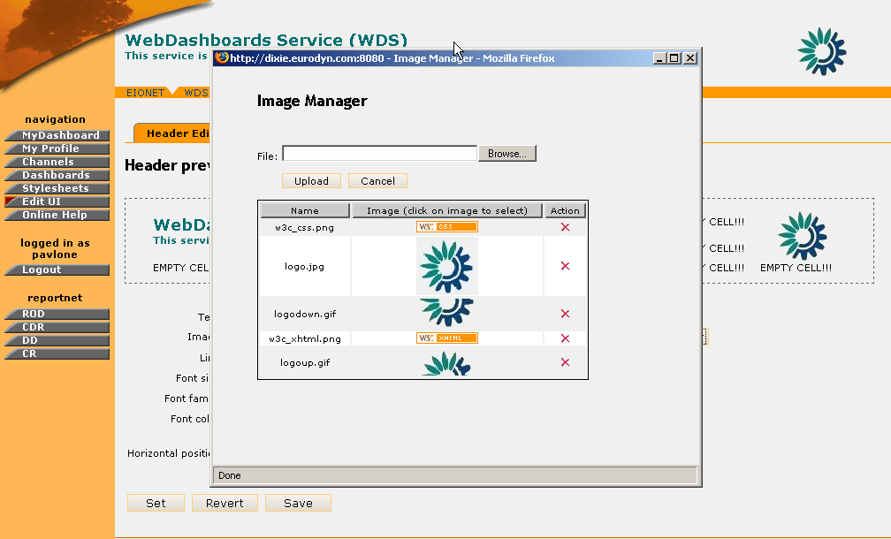
Figure 27: Image Manager

If the cell already contains some information, this is going to be displayed in the input fields upon the cell’s selection.

STEP 4 – Preview the New Settings
In order for the user to preview the new settings for the Header/Footer, the “Set” button must be pressed. Instantly, the preview matrix will be updated with the new data.

STEP 5 – Save/Revert new Settings
If the user wishes to bring back the initial settings for the Header/Footer, then the “Revert” button must be selected. This will bring the matrix cells to the state that is saved in the WDS database.
However, if the user is happy with the new Settings and wishes changes to take effect WDS-wide, then the “Save” button must be selected.

*Important Note: After the “Save” button is selected, the saved matrix state in the database is overwritten. Selecting the “Revert” action will bring the Header/Footer matrix back to this saved state.

In summary:

Step | Edit Notification Template
1 | Login
2 | Click on “UI Manage” button
3 | Select and Edit Matrix Cell
4 | Preview the New Settings
5 | Save/Revert New Settings

WDS User FEATURES

General Principles

The user module section describes the set of WDS operations and functions which are available to simple non-administrator users. This set of functions allows REPORTNET users to manage their dashboard profile information. More precisely, it allows registered users to view their dashboard and specify which channels they wish to view in it.
This set of functions is comprised of the following:
- Manage Profile Preferences
- View Dashboard

View Dashboard

Access the Dashboard

In the “My Dashboard” section, the user may view the channels that correspond to his/her Dashboard profile settings.
In order to view the dashboard channels, the user does not have to login every time. On the contrary, the user needs to login only once. Upon that login, a cookie is stored on the user’s PC and will allow the user to view the dashboard freely.

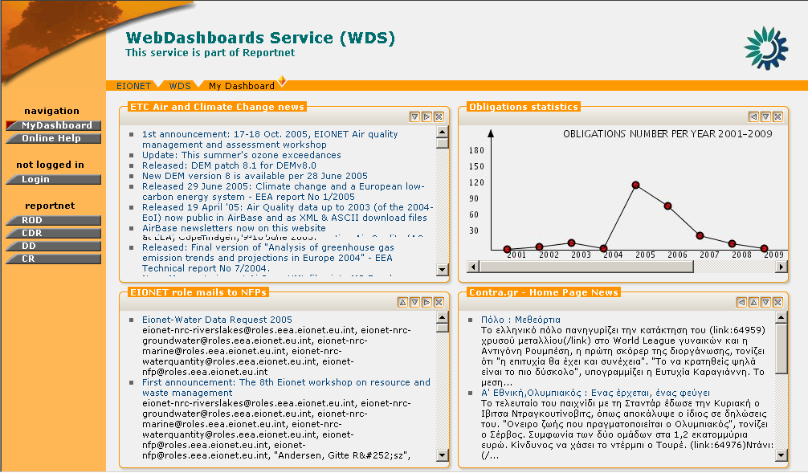
Figure 28: A user can access the dashboard without being logged in.

Move items on the dashboard

As mentioned in the Manage Dashboard Profile Preferences section, the user can define the number of columns in which channels are displayed.
Additionally, the user may also modify the order in which channels are displayed.
For every channel, there exist a series of function buttons which control the position of the channel in the dashboard.
Figure 29: Dashboard Channel Direction functions

With these function buttons; the user can move the channel in all four directions relatively to the rest of the channels. For example, in Figure 30, the “Obligations statistics” channel has been moved to the left and the channel which occupied this place prior to this action was moved downwards.
In addition to the direction buttons, there exists a close button denoted by: “x”. Pressing this button will not only close the channel but also remove it from the user’s Dashboard profile. In order for the channel to appear again, the user must re-select it from the dashboard profile management options.

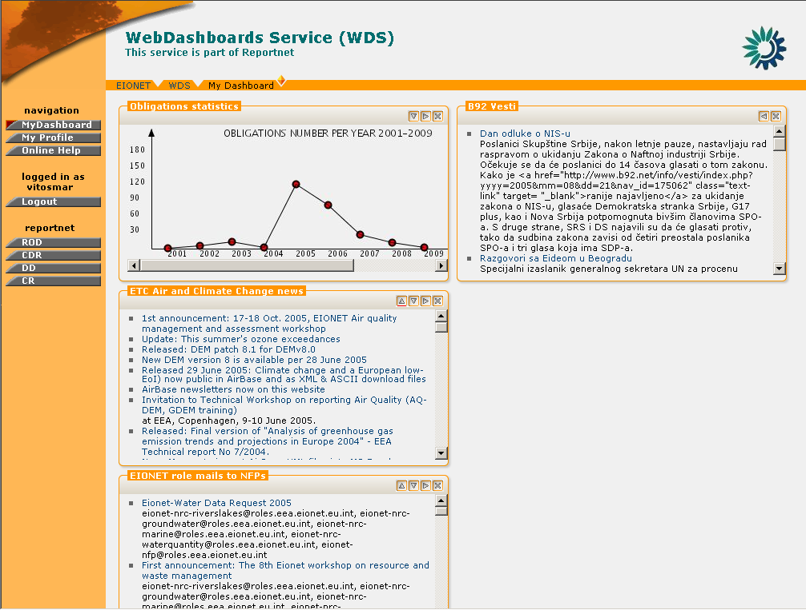
Figure 30: My Dashboard - Channel Move

The PUSH Channels

The PUSH channels are dedicated to users that to receive data sent by External systems on their dashboard. Such an example is the Unified Notification Service channel where the harvested events from all UNS channels which have the WDB delivery option are displayed.
The users have the ability to personalize the amount of time that the pushed articles will stay on the channel by pressing on the “edit” button on the channel’s menu. The PUSH channels are the only channels in the Dashboard to have such a button.
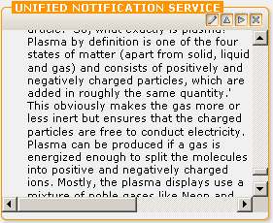
Figure 31: UNS channel and "edit" button

By selecting the “edit” button, the user will arrive at the “Edit User Channel” page where it is possible to specify the maximum time for which an article can stay on the PUSH channel. This value cannot be set to more than 60 days.

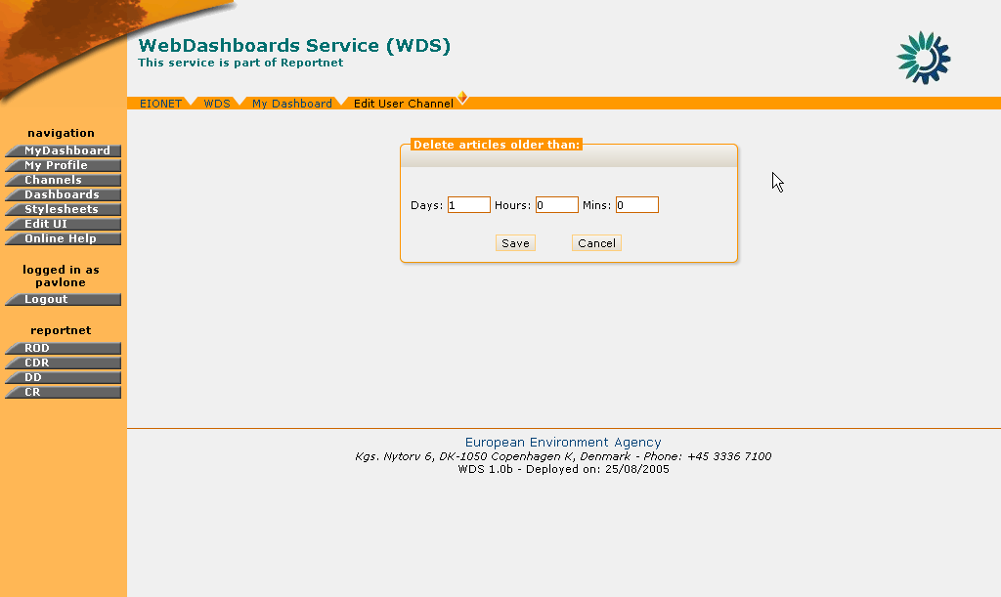
Figure 32: UNS Channel edit page

Manage Dashboard Profile

Manage Dashboard Profile Preferences

In order to manage your dashboard profile preferences, the user must be logged in WDS.
If the user has the required user credentials, then the following steps must be followed:

STEP 1 – Login
If you are not already logged in, see Authenticate User Account.

STEP 2 – Click on “My Profile” button on the navigation bar.
View the “Profile Preferences” tab
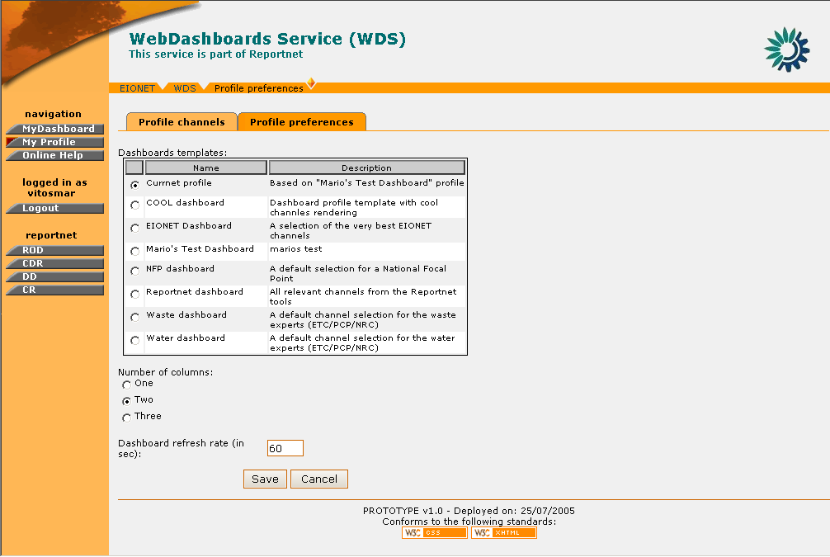

Figure 33: Profile preferences

STEP 3 – Select dashboard template
The “Profile Preferences” page displays all the available dashboard templates.
The user can select one template.

STEP 4 – Specify Number of columns
This is the number of columns according to which the content channels will be displayed in the user’s dashboard. The user may select splitting the channels among 1, 2 or 3 columns.

STEP 5 – Specify Dashboard Refresh Rate
The user may define the rate (in seconds) in which the dashboard will be refreshed with new data.

In summary,

Step | Manage Dashboard Profile Preferences
1 | Login
2 | Click on “My Profile” button
3 | Select a Dashboard Template
4 | Specify Number of Columns
5 | Specify Refresh Rate

Manage Profile Channels

In addition to the channels defined in the dashboard template, the user may insert additional channels to his/her dashboard profile.

In order to do so, the user must be logged in WDS.
If the user has the required user credentials, then the following steps must be followed:

STEP 1 – Login
If you are not already logged in, see Authenticate User Account.

STEP 2 – Click on “My Profile” button on the navigation bar.
In order to manage the dashboard profile channels, the user should select the “Profile Channels” tab

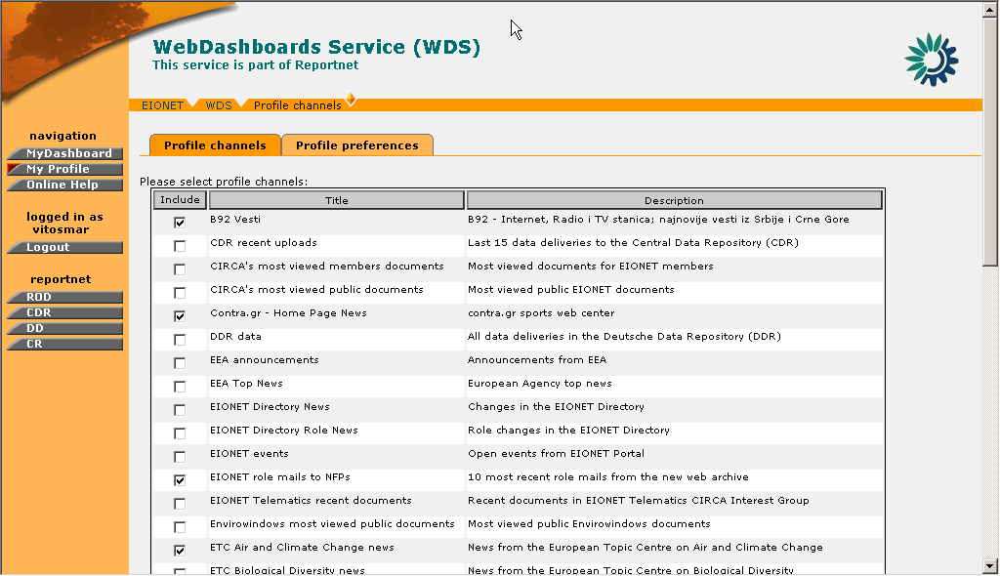

Figure 34: Profile Channels

STEP 3 – Select Channels
The user will view the channels which he/she is allowed to access according to the user class. The user can tick any channels on the list in order to add them on the dashboard profile.
The channels that are already present in the user’s dashboard profile are already ticked.

STEP 4 – Save Dashboard Profile
After the user has selected all desired channels, the “Save” button must be selected in order for the new settings to take effect. After the save operation, the user is redirected to his/her dashboard.

In summary,

Step | Manage Profile Channels
1 | Login
2 | Click on “My Profile” button
3 | Select Channels
4 | Save Dashboard Profile

RPC User FEATURES

The group of RPC users represent external systems which interact with the WDS application.
These client applications may perform the following operations on WDS:
- Create PUSH channels by using XML-RPC or Web UI,
- Push events to those channels by using XML-RPC and
- See list of their channels on the WDS web Site.

WDS XML-RPC

In the context of the WDS, XML-RPC can be used to send RDF formed data to the WDS and to create PUSH channels that will be used for the insertion of data. These operations are allowed only to the registered WDS RPC users.

The UNS XML RPC Routers are:
- http://<<Web Dashboards Domain>>/do/xml-rpc (authentication required)
- http://<<Web Dashboards Domain>>/do/*/dashboard/xml-rpc (authentication not required)
Data sent to the WDS by using router 1) may be accessed by all users who may have privileges to include a used channel in the dashboard profile.
Router 2) is used to send data related to the specific user. ‘*’ represents the username of the REPORTNET user. Therefore, REPORTNET users will be able to see data only related to them and not to other users.

Currently there are two procedures available to the WDS RPC users:
- push(channel_id, rdf_message): This sends RDF formed message to the WDS. It takes as parameters the identifier of the channel where data will be sent (channel_id) and the RDF formed data (message). This method can be invoked only by using both URLs.
- createChannel(channel_name, description): Creates new PUSH channel. It takes as parameters the name of the new channel (required) and its description (the phrase describing the purpose of the channel). This method can be invoked only by using URL 1.

In case of errors WDS will return the following common HTTP status codes:
- “ServiceUnavailable" 503 (Will be returned in case that remote service is trying to push data to the existing but disabled channel)
- "NotFound" 404 (Will be returned in case that remote service is trying to push data to the non existing channel)
- "BadRequest" 400 (Will be returned in case that remote service is trying to provide bad input to the UNS)
- "InternalError" 500 (Will be returned in case of internal WDS errors)
- "Unauthorized" - 401 (Will be returned if remote service is unauthorized to perform desired operation)

To make use of the WDS XML RPC, the users need to call it from an application. The following is an example for such an RPC call using the Python programming language:

import xmlrpclib

addr= http://<<Web Dashboards Domain>>/do/xml-rpc
server = xmlrpclib.Server(addr,BasicAuthTransport(user,password))
try:
server.WDSXmlRpcService.push(‘UNS’,rdfMessage)
except xmlrpclib.ProtocolError, p:
err_code=p.errcode
#handle error according to error code

WDS RPC Users UI

As mentioned in the introduction of this section, the RPC users may view only the list of the channels they have created, or create a new PUSH channel.

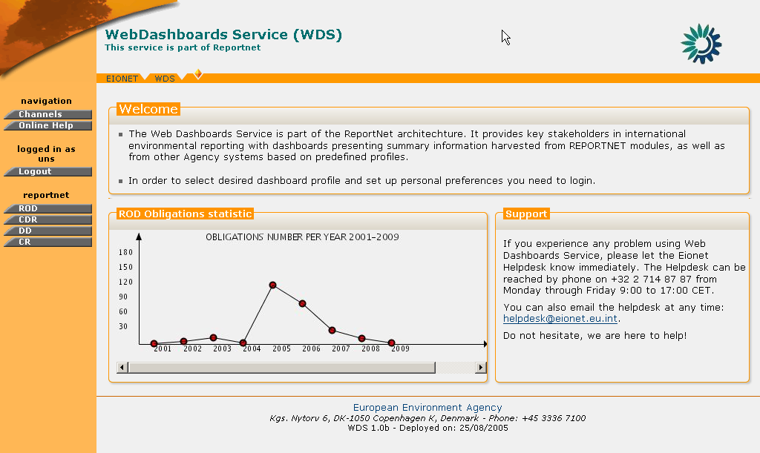
Figure 35: RPC User welcome screen

RPC User PUSH Channel Creation

In order to create a PUSH channel, the user must be logged in WDS as RPC User.
If the user has the required user credentials, then the following steps must be followed:

STEP 1 – Login
If you are not already logged in, see Authenticate User Account.

STEP 2 – Click on “Channels” button on the navigation bar.
This will take you to the list of the existing PUSH channels for the corresponding user. The identifier of the channel which is required for insertion of events as well as the Channel status are the two additional columns displayed in this list.

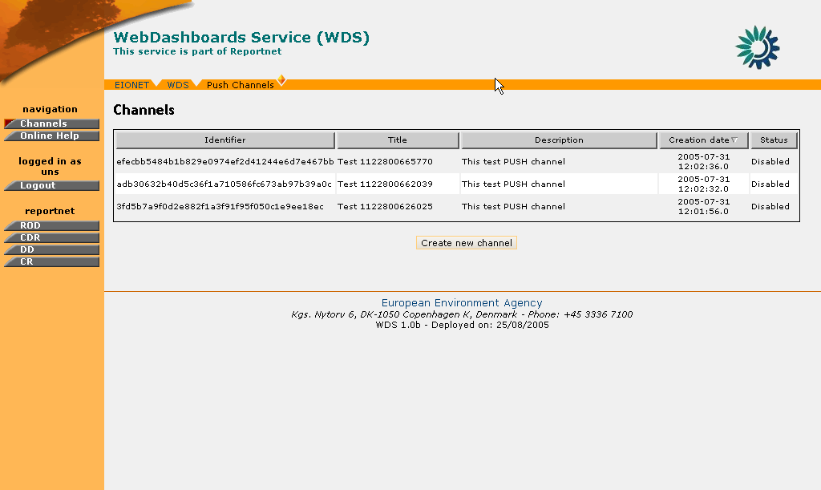
Figure 36: PUSH Channels List

STEP 3 – Click “Create”
By clicking on the Create button, the user arrives at the PUSH channel creation dialogue. A channel name and description must be entered by the RPC user in order for the channel to be created.

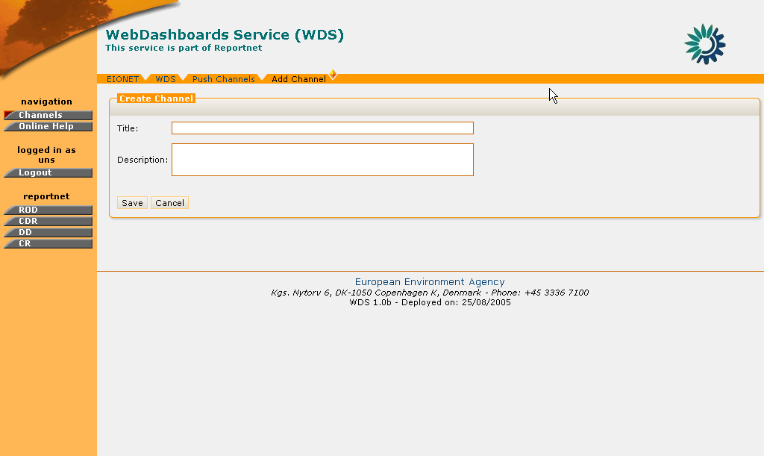
Figure 37: PUSH Channel Creation form

STEP 4 – Finalize PUSH Channel creation
After all the required data have been inserted, the user must press the “Save” button in order for the channel to be created.

So, in summary:

Step | RPC User PUSH Channel creation
1 | Login
2 | Click on “Channels” button
3 | Click “Create” button
4 | Finalize PUSH Channel creation

[END OF DOCUMENT]

Action: I = Insert; R = Replace; C = Creation
This list is not exhaustive. The full RSS specification can be found at http://blogs.law.harvard.edu/tech/rss
Complete specifications for RDF are found at: http://www.w3.org/RDF/

